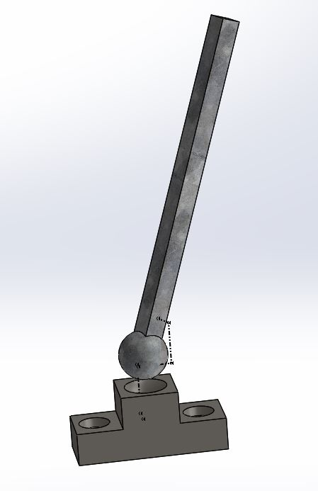

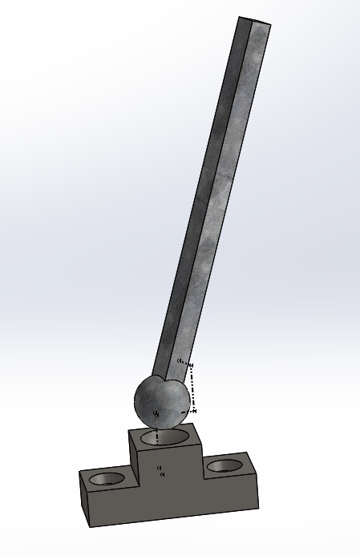

Step 1: Ball and socket will be premanufactured using a cast

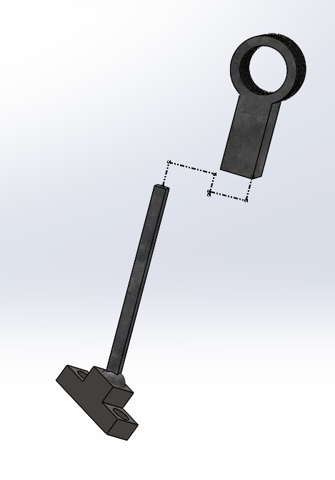

Step 2: Slide the Upper arm joint onto the hydraulic arm of the ball joint

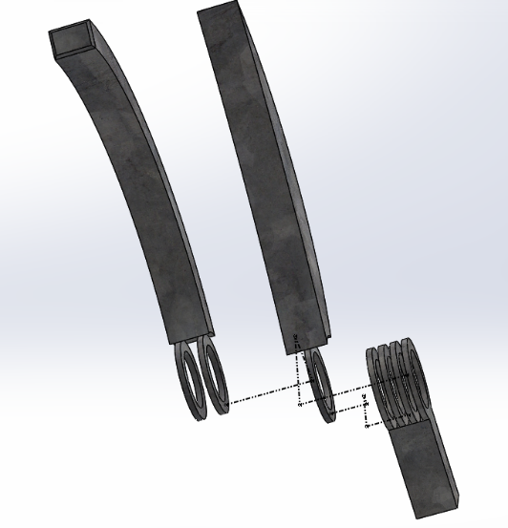

Step 3: Slide the Upper arm and Upper pincer into the slots of the upper arm joint. The pincer should slide into the central slot. The upper arm should slide into the two slots on either side of the center.

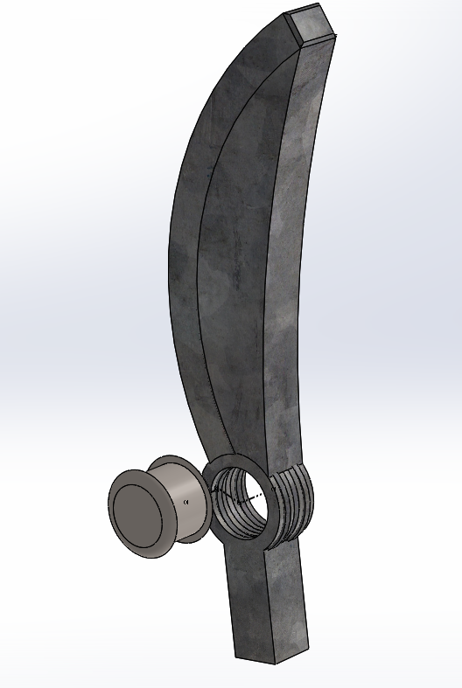

Step 4: Insert the Hinge pin into the central hole of the Upper arm, Upper pincer, and upper arm joint.

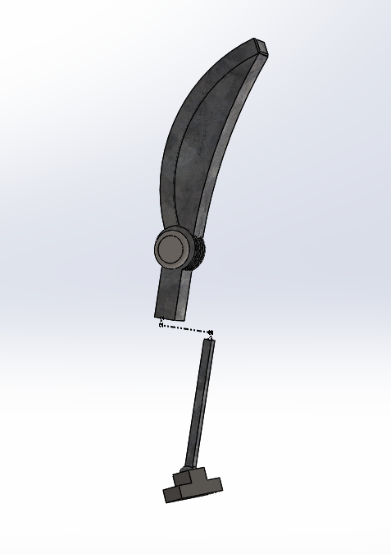

Step 5: complete the assembly by sliding the upper joint assembly onto the ball joint arm.